**SYSTEM DESIGN & SOLUTION BLUEPRINT DOCUMENT**

**FOR THE IMPLEMENTATION OF AN INTEGRATED MANAGEMENT INFORMATION SYSTEM**

**CONTRACT REFERENCE NO: CUE/059/2018-2019**

**PRESENTED TO**



|  |
| --- |
| COMMISION FOR UNIVERSITY EDUCATION  Redhill Rd. Off Limuru Rd. Gigiri  P.O. BOX 54999-00200  NAIROBI-KENYA |

**SUBMITTED BY**

|  |  |  |
| --- | --- | --- |
| |  |  | | --- | --- | | finalwithLtdCompressed |  |   DYNASOFT BUSINESS SOLUTIONS LTD  WEST END PLACE, 3RD FLR, OFF LANGATA ROAD  P.O. BOX 3209-00506  NAIROBI, KENYA  Tel: +254 020 2100809/+254725548246 / +254721822096  [admin@dynasoft.co.ke](mailto:admin@dynasoft.co.ke) |

**DATE: MONDAY, 14TH JANUARY, 2019**

**TABLE OF CONTENTS**

*Table of Contents*

**TABLE OF CONTENTS** 2

**SIGN OFF PAGE AND DOCUMENT VERSIONS** 4

**DOCUMENT VERSIONS** 5

**PROJECT DEFINITION** 7

**SECTION A: EXECUTIVE SUMMARY** 8

**1.1.** **Background information** 8

**1.2.** **Purpose of the Conceptual model, system design and solution blueprint document** 8

**1.3.** **Scope of the system design & solution blueprint** 8

**1.4.** **System design priorities** 9

*1.4.1.* *Integration* 9

*1.4.2.* *Usability* 10

*1.4.3.* *Maintainability* 10

*1.4.4.* *Security* 10

**1.5.** **Deliverable** 10

**SECTION B: SOLUTION ARCHITECTURE** 11

2.1. Global architectural model 11

**2.2** **NETWORK ARCHITECTURE** 15

**SECTION C: DATAFLOW & ENTITY RELATIONSHIP MODEL** 17

**3.1** **INTERNAL (INTER-DEPARTMENTAL) INFORMATION FLOW MODEL** 17

**3.1.1** **Conceptual model for internal information flow** 17

**3.1.2** **Conceptual model for internal information flow** 17

**SECTION D: CONCEPTUAL BUSINESS PROCESS MODELS FOR ACCREDITATION** 19

**4.1** **System process description(Institution)** 19

**4.3.** **Conceptual system design** 22

**4.5.** **System Process Description(program)** 25

**5.1. Proposed Database design** 33

**6.1.** **System process maps for Quality Audit module** 36

**6.2.** **Proposed Database design** 36

**SECTION I: CONCEPTUAL BUSINESS PROCESS MODELS FOR FINANCIAL MANAGEMENT** 38

**7.1 Summary of core Financial Management** 38

**7.1.1 Conceptual process map: Budgeting** 39

**7.1.2 Conceptual process map: Receipting** 40

**7.1.3 Conceptual process map: Petty cash administration** 41

**7.1.4. Conceptual process map: Imprest administration** 42

**7.2 Conceptual system design** 43

**7.3 Proposed Design** 45

Budget 45

Receipting & Payment Voucher 46

Imprest management 48

**SECTION K: THE PROPOSED NAV 2018 SOLUTION DESIGN** 49

**8.1 Conceptual model: financial management module** 49

**8.1.1 Detailed navigation design for the financial management module** 49

**SECTION L: THE BACK-END DATABASE DESIGN** 53

**9.1 Database management system design summary** 53

**SIGN OFF PAGE AND DOCUMENT VERSIONS**

|  |  |
| --- | --- |
| **CLIENT: COMMISSION FOR UNIVERSITY EDUCATION(CUE)** | |
| **PROJECT SPONSOR:**  **NAME: PROF. MWENDA NTARANGWI**  **TITLE: COMMISSION SECRETARY**  **SIGNATURE………………………...................................**  **DATE………………….....................................................** | **CLIENT PROJECT MANAGER**  **NAME: PROF. WALTER OYAWA**  **TITLE: PROJECT MANAGER**  **SIGNATURE: …………………….....................................**  **DATE…………………........................................................** |
| **ICTA REPRESENTATIVE**  **NAME: MARY KEREMA**  **SIGNATURE ………………………...................................**  **DATE………………….....................................................** | **ICT MANAGER**  **NAME: DR. FRANCIS KIBARU**  **SIGNATURE: ………………………...................................**  **DATE………………….....................................................** |
| **RISK/AUDIT REPRESENTATIVE**  **NAME: PHYLLIS KARIMI**  **SIGNATURE: ……………………...................................**  **DATE …………….....................................................** |  |

|  |  |
| --- | --- |
| **DYNASOFT BUSINESS SOLUTIONS LTD** | |
| **CONTRACT LEAD**  **NAME: GILBERT KIPLAGAT KUGUN [CHIEF EXECUTIVE OFFICER]**  **SIGNATURE: ……………………...................................**  **DATE………………….....................................................** | **SOLUTION ARCHITECT**  **NAME: USHINDI STEPHEN [CHIEF OPERATING OFFICER]**  **SIGNATURE: …………………….....................................**  **DATE…………………........................................................** |
| **ENGAGEMENT CONSULTANT**  **NAME: DR DAN ORWA (CHANGE MANAGEMENT & QA)**  **SIGNATURE…………………………………………….**  **DATE:………………………………………………..** | **RELATIONSHIP MANAGER**  **NAME: TERRY OBI**  **SIGNATURE………………………….**  **DATE……………………………….** |
| **PROJECT MANAGER**  **NAME: JOSEPH MUTURI (PROJECT MANAGER)**  **SIGNATURE ………………………………………………**  **DATE ………………………………………………………** | **TECHNICAL CONSULTING LEAD**  **NAME: ERICK DAUDI [HEAD OF TECHNICAL SERVICES]**  **SIGNATURE ………………………………………………….**  **DATE …………………………………………………………** |
| **LEAD DEVELOPER**  **NAME: AULERIAH MWANGI (HEAD OF IMPLEMENTATION)**  **SIGNATURE ………………………………………………**  **DATE ………………………………………………………** | **LEAD IMPLEMENTER**  **NAME: RUTH MACHIRA (SYSTEMS IMPLEMENTER)**  **SIGNATURE ………………………………………………**  **DATE ………………………………………………………** |

**DOCUMENT VERSIONS**

The table below summarizes the document version for the Conceptual model, system design and solution blueprint document in line with the documentation standards adopted by Dynasoft Business Solutions Ltd.

|  |  |  |
| --- | --- | --- |
| **Version/Reference** | **Document Date** | **Any additional information** |
| Version 1.0 | 14th January, 2019 | Version 1 of the Conceptual Model, System Design & Solution Blueprint Document |

**ABBREVIATIONS LIST**

Below is a list of abbreviations used in this document:

|  |  |
| --- | --- |
| **ABBREVIATION** | **MEANING** |
| DB/SL | Declining-balance and Straight-line depreciation methods |
| DYNASOFT | Dynasoft Business Solutions Ltd |
| FRD | Functional Requirements Document |
| G/L | General Ledger |
| NAV | Microsoft Dynamics NAV 2018 |
| MS | Microsoft |
| P&L | Profit and loss Statement |
| RAS | Requirements Analysis and Specification |
| KRA | Kenya Revenue Authority |
| SQL | Structured query Language |
| VAT | Value Added Tax |
| WIP | Work In Progress |

**PROJECT DEFINITION**

|  |  |
| --- | --- |
| **PROJECT NAME:**  **Supply, installation, implementation, testing, training and commissioning of an integrated management information system** | **CLIENT:**  COMMISION FOR UNIVERSITY EDUCATION  Redhill Rd. Off Limuru Rd. Gigiri  P.O. BOX 54999-00200  **ERP SYSTEMS CONSULTANT:**  Dynasoft Business Solutions Ltd  West End Place, 3rd Floor, Off Langata Road  P.O. Box 3209-00506 Nairobi-Kenya |
| PROJECT CATEGORY: Integrated management information system  KEY MODULES: Accreditation, Data collection, Quality Audit & Financial Management.  DELIVERABLE: Design and solution blueprint document  DOCUMENT DATE: 14th January, 2019 |
| **CLIENT PROJECT STAKEHOLDERS** | |
| **EXECUTIVE SPONSOR: COMMISSION FOR UNIVERSITY EDUCATION(CUE)** | |
| **KEY PROJECT STAKEHOLDERS**   1. Prof. Mwenda Ntarangwi-Project Sponsor/Commission Secretary 2. Prof. Walter Oyawa- Client Project Manager 3. Dr. Francis Kibaru-Client ICT Lead 4. Linah Lilan-Lead User (Finance) 5. Prof. Jackson Too-Lead User (University Data Collection | 1. Joseph Musyoki-Lead User (Program Accreditation/Institutional Accreditation) 2. Daniel Ogutu- Lead User (Program Quality Audit/Institutional Quality Audit) 3. Mary Kerema -ICTA Representative 4. Phyllis Karimi -Risk/Audit/Procurement Representative |
| **ERP CONSULTANTS: DYNASOFT BUSINESS SOLUTIONS LTD** | |
| 1. Gilbert Kugun-Contract Lead 2. Ushindi Stephen-Solution Architect 3. Dr. Dan Orwa-Engagement Consultant (Change Management & QA) 4. Joseph Muturi-Project Manager 5. Erick Daudi-Principal Technical Lead 6. Ruth Machira-Lead Implementer | 1. Auleriah Mwangi-Lead Developer 2. Shawn Mbuvi -Portal Developer 3. David Muthoka-Project Accountant 4. Obi Terry-Relationship Manager |

**SECTION A: EXECUTIVE SUMMARY**

* 1. **Background information**

Commission for University Education formally contracted Dynasoft Business Solutions Ltd

to undertake the implementation of integrated management information system

solution to support the core business operations of the board.

Conceptual design and solution modeling was conducted by Dynasoft consulting team to depict the proposed design to meet the key user requirements that had been captured and documented in the functional requirements document. The FRD document, signed off by both CUE and Dynasoft, thus served as the input reference document for the system design phase.

* 1. **Purpose of the Conceptual model, system design and solution blueprint document**

To document the proposed global and detailed Conceptual model, system design and solution blueprint that matches the user requirements that were captured and signed off in the functional requirements document

* 1. **Scope of the system design & solution blueprint**

The system design and conceptual data flow modeling was done to cover the following 4 core functions for CUE, namely:

1. Accreditation process
2. Financial management
3. Quality Audit
4. Data Collection

The scope of the integrated management information system deployment was to cover CUE main office and all accredited institutions country wide

The system design phase was organized to separate standard functionality provided by NAV from customized enhancements made by the consulting team to suit the user requirements of CUE.

The schematic diagram below shows the standard and customized functions that form the solution blueprint:

|  |
| --- |
|  |

* 1. **System design priorities**

The design process for the NAV solution deployed at CUE was governed by the following priorities among many other considerations:

|  |
| --- |
| * + 1. *Integration*   The Microsoft Dynamics NAV 2018 solution shall have different but interdependent modules that will work together to support the core operations of CUE. The core modules to be integrated include financial management, accreditation, quality audit and data collection.   * + 1. *Usability*   The system design was governed by the philosophy of making the final solution easy to use while meeting its core functional requirements. The goal was to develop an easy-to-use system supporting access to and sharing of information relevant for the finance, accreditation, data collection and quality audit at CUE.   * + 1. *Maintainability*   The system design adopted for the NAV system is modular and highly parameterized for ease of maintenance of each module and localization of any bugs that JUNE occur.   * + 1. *Security*   Due to the confidentiality and financial-nature of the information handled by CUE, it was of great priority to ensure security of the information stored by the NAV system. The three-tier architecture to be adopted for the deployment of the system guarantees security at its service tier level. The Service tier enforces security by performing authentication roles and validating all user requests before passing them to the other tiers. Furthermore, application-level security shall be enforced using user profiling. The system shall also provide an audit trail facility to track all changes made in the system. |

* 1. **Deliverable**

In reference to the Project plan, the deliverable of the system design phase is this Conceptual model, system design and solution blueprint document.

**SECTION B: SOLUTION ARCHITECTURE**

## 2.1. Global architectural model

Microsoft Dynamics NAV 2018 system is based on a three-tier architectural framework where the top tier is the GUI-enabled client interface that is resident on a normal end user machine. The client interface is the platform responsible for the processing of user requests or general queries sent to or received from the business logic tier. The business logic component, which is the middle tier, processes all transactions covering the following core areas:

1. Accreditation process
2. Financial management
3. Data Collection
4. Quality Audit

The business logic tier receives, processes, and retrieves information by accessing the bottom tier, the Database. The solution shall be built on Microsoft SQL Server 2017 Standard Edition as the backend database management system.

**Client Tier (Windows/Web/Mobile/App)**

**NAV Service Tier (NAV Application Server)**

**Supports multiple NAS servers to improve**

**performance**

**Data Tier**

**Azure platform (Hosted at ICTA)**

Portal, File Management and Encryption

Applications

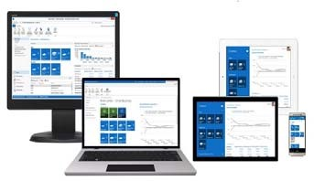

**2.1.1 Client Tier**

The GUI-enabled client interface is the platform responsible for the processing of user requests or general queries sent to or received from the business logic tier. The client tier provides a frontend for the users so that they can work within NAV. NAV 2018 provides several clients you could work with such as the Windows client, Web client and

|  |  |
| --- | --- |
| Client Option | Features & capabilities |
| Microsoft Dynamics NAV Windows client- | The Microsoft Dynamics NAV Windows client is an intuitive and versatile Windows application that can be customized to support the job functions of a full range of work roles in an organization. Each role is mapped to a customizable Role Center that displays key information required for relevant users and makes their day-to-day tasks easier to complete. Users run the Role Tailored client to find the information and data entry points that their jobs require. The Microsoft Dynamics NAV Windows client is installed when you select the Demo Option, Client Option, or Developer Option in Microsoft Dynamics NAV Setup. The Microsoft Dynamics NAV Windows client is available in a 32-bit version and 64-bit version. The 32-bit version of the Microsoft Dynamics NAV Windows client can be run on either a 32-bit or 64-bit version of a Windows operating system. The 64-bit version of the Microsoft Dynamics NAV Windows client can only be run on a 64-bit version of a Windows operating system. On a 64-bit Windows operating system, the 64-bit version of the Microsoft Dynamics NAV Windows client is used by default, but you can to run the 32-bit version as well. |
| Microsoft Dynamics NAV Web client | The Microsoft Dynamics NAV Web client is an alternative to the Microsoft Dynamics NAV Windows client that enables you to access Microsoft Dynamics NAV data over the Internet. From a web browser, you can view and edit data by using an interface that is similar to the Microsoft Dynamics NAV Windows client. |
| Microsoft Dynamics NAV Tablet & Phone client | The Microsoft Dynamics NAV Tablet client and Microsoft Dynamics NAV Phone client allow authorized users in small to access data from a tablet or a phone. |

* + 1. **NAV Service Tier (NST)**

The NAV service tier consist of a multithreaded Windows Service which is running as Microsoft Dynamics Server that handles all the authentication, business logic, communication and system caching capabilities.

Microsoft Dynamics NAV Server is a .NET-based Windows Service application that works exclusively with SQL Server databases. It uses the Windows Communication Framework as the communication protocol for Role Tailored clients and for Web services. It can execute multiple client requests in parallel and serve other clients by providing Web service access to authenticated clients. Microsoft Dynamics NAV Server provides an additional layer of security between the clients and the database. It leverages the authentication features of the Windows Communications Framework to provide another layer of user authentication and uses impersonation to ensure that business logic is executed in a process that has been instantiated by the user who submitted the request. Authorization and logging of user requests is still performed on a per-user basis. This ensures that all Windows authentication and Microsoft Dynamics NAV roles and permissions that have been granted to the user are correct. It also ensures that business logic–level auditing is still performed.

The NAV Service Tier runs the NAS service, OData web services and SOAP web services. The section below summarizes the role of each NST component:

|  |  |
| --- | --- |
| NST Service | Description |
| NAS Services | NAS services are a middle-tier server component that executes business logic without a user interface or user interaction. NAS services are intended for task scheduling, client offloading, and specialized integration scenarios. |
| OData Web Services | OData services are recommended for client applications that require a uniform, flexible, general purpose. They are less suited for applications that are primarily method-oriented or in which data operations are constrained to certain prescribed patterns. OData supports Representational State Transfer (REST)-based data services, which enable resources, identified using Uniform Resource Identifiers (URIs), and defined in an abstract data model (EDM), to be published and edited by web clients within corporate networks and across the Internet using simple Hypertext Transfer Protocol (HTTP) messages. OData services are lightweight, with functionality often referenced directly in the URI. You define and publish Microsoft Dynamics NAV 2018 OData web services in the Role Tailored client, and manage them from the Microsoft Dynamics NAV Server Administration tool. |
| SOAP Web Services | SOAP web services allow full flexibility for building operation-centric services. This includes industry standard interoperability, as well as channel and host plug-ability. For web services that must interoperate with Java or use channels other than HTTP, SOAP services are the only option. Windows Communication Framework (WCF) has supported SOAP services since its initial release in .NET Framework 3.0, and .NET Framework 4 adds additional support and default bindings to make it easier to build SOAP services using WCF. You define and publish Microsoft Dynamics NAV 2018 SOAP web services in the Role Tailored client, and manage them from the Microsoft Dynamics NAV Server Administration tool |

* + 1. **Data Tier (Microsoft SQL Server)**

The data tier consists of Microsoft SQL Server with a Dynamics NAV database. For NAV 2018 you need to have at least SQL 2012 or newer. The data tier stores all the business data. SQL Server, augmented by Microsoft Dynamics NAV 2018 database components, is the data tier.

* 1. **NETWORK ARCHITECTURE**

In a typical network environment such as CUE’s, there is a secured company domain which contains the company computers (host machines) and this domain is usually protected with a firewall or proxy.

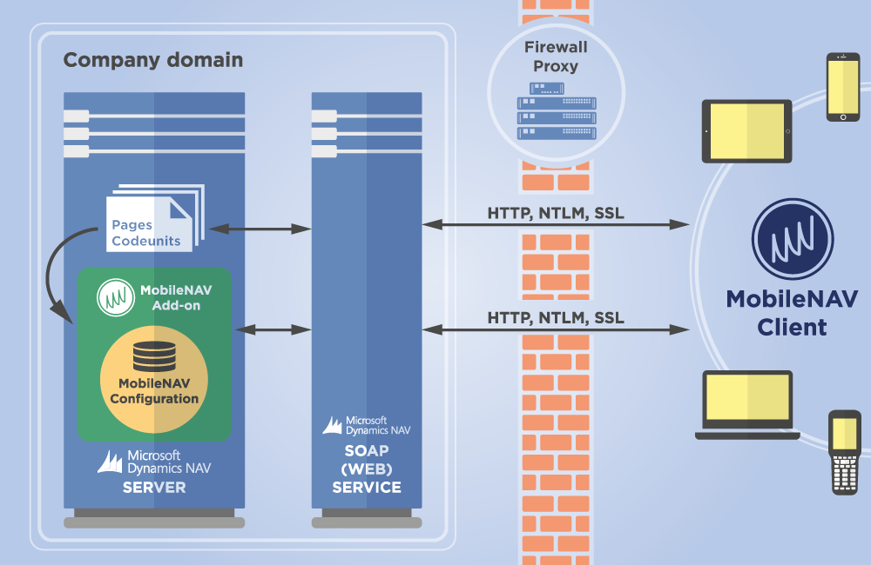

However, NAV requires that some access is allowed for devices that shall be outside the CUE network. In this regard, the system has been designed to support the following network architecture:

|  |
| --- |
| Image result for laptop & desktop  Host Machine |
| NAV Web Client network architecture |

The section below summarizes the 5 main components of the NAV 2018 network architecture:

|  |  |
| --- | --- |
| Network Tier | Description |
| Device | This refers to a computer or device that has access to the Internet with a browser and is used to access NAV using the NAV Web Client or through the App. |
| Host Machine | This refers to an on premise computer or device that runs NAV 2018 Windows Client within the local network environment. |
| Web Server | A computer that is running Internet Information Services (IIS) at a minimum. Microsoft Dynamics NAV Web Server components are installed on a website on IIS. |
| Microsoft Dynamics NAV Server (NST) | A Microsoft .NET Framework–based Windows Service that manages communications and provides a security layer between clients and Microsoft Dynamics NAV databases in SQL Server. |
| Database | A SQL Server database that contains Microsoft Dynamics NAV |

**SECTION C: DATAFLOW & ENTITY RELATIONSHIP MODEL**

1. 1. **INTERNAL (INTER-DEPARTMENTAL) INFORMATION FLOW MODEL**
      1. **Conceptual model for internal information flow**

The section below provides the interdepartmental information flow model supported on the Navision system:

* + 1. **Conceptual model for internal information flow**

The section below provides the interdepartmental information flow model supported on the NAV system:

|  |  |
| --- | --- |
| * + - 1. Current Relationships | |
| Department | **General Operations and Information Flow** |
| Finance Department | 1. Contract management 2. Payroll 3. Interest income 4. Cash book 5. Fixed asset 6. General ledger 7. Budgeting 8. Imprest management 9. Accounts receivable 10. Accounts payable |
| Accreditation | 1. Institution Accreditation 2. Program accreditation |
| Data Collection | 1. Enrollment 2. Foreign students 3. Research 4. County/Regions 5. Disability 6. Finance 7. Graduation 8. Resources 9. Staffing |
| Quality Audit | 1. Quality audit for institution |

**SECTION D: CONCEPTUAL BUSINESS PROCESS MODELS FOR ACCREDITATION**

## 4.1 **System process description(Institution)**

The System Process model below shows the accreditation process.

1. The process is initiated by the institutions sponsor.
2. A form is filled which includes the following:
   1. Institution details, including the type of institution applying:
      1. Campus
      2. ODEL and Online Institutions
      3. Public/Private University (Need to track category such as Interim, Chartered etc.)
      4. Constituent College
      5. Specialized Degree-awarding Institutions
   2. Programs that will be offered by the institution
3. A cove letter is attached.
4. A proposal document is attached-this details the wider narrative of what the institution/program entails.
5. Payment is made about the type of accreditation i.e.
   1. Public universities- Kshs. **410 ,000.**
   2. Campus- Kshs. **150,000.**
6. The applicant provides the payment document i.e. bank deposit slip.
7. The application is forwarded to processing departments (Institution accreditation) for preliminary checks (completeness checks).
8. A panel is selected from a pre-qualified number of experts, resources etc.
9. On panel selection, a peer review is conducted which involves subject experts’ evaluation on ground to ensure mentioned standards filled in the institution details match with the ground situation.

This is to ensure the minimum requirements are met.

1. On board approval stage, the board members may either approve or reject the application. On approval the institution is awarded the accreditation certificate. The institution has to operate for a period before being awarded the charter. On rejection, the application goes back to peer review/evaluation stage. The possible verdicts are:
   * 1. **Redesign**
        1. Based on exit report and new checklist (Applicant must re-submit within 90 Days)
        2. System creates a Re-design application that references the original proposal form (Possibility of being a free or billable service)
        3. Tag deadlines for next inspection after re-design verdict (90 Days after)
     2. **Major Revamp**
        1. Based on exit report and new checklist (Applicant must re-submit within 45 Days)
        2. System creates a Re-design application that references the original proposal form (Possibility of being a free or billable service)
        3. Tag deadlines for next inspection after major revamp verdict (45 Days after)
     3. **Minor Revamp**
        1. Based on exit report and new checklist (Applicant must re-submit within 21 Days)
        2. System creates a Re-design application that references the original proposal form (Possibility of being a free or billable service)
        3. Tag deadlines for next inspection after minor revamp verdict (21 Days after)

This stage can last if the institution has not complied with the minimum standards.

1. Feedback is sent to the applicant informing them of success or of the improvements required for successful accreditation.
   1. **System Process map**

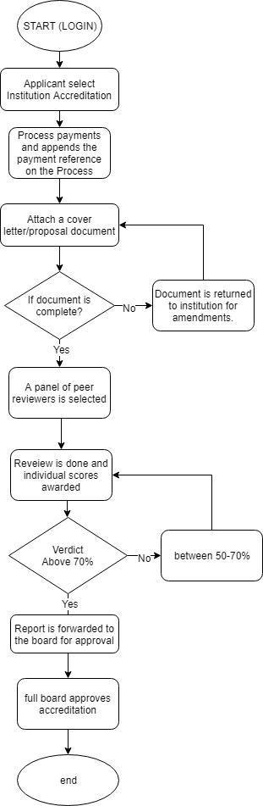

## **Conceptual system design**

This section summarizes the process flow of the accreditation module:

|  |  |
| --- | --- |
| **Process/Function** | **Design approach** |
| Applicant registers through the portal. Completes the online application with details. | * Categories of accreditation: institution, Program * Enforcement of completeness of the form (mandatory fields) * On application the system should have the ability to save the online application for completion at a later time. (drafting). * Ability to attach supporting documents e.g. cover letter, proposal document |
| Applicant pays the application fees as per the application fee schedule. | * Upon selection of the accreditation type, the system should display the amount of fee to be paid. * System should validate payment method * E-receipting/payment Notification-Acknowledging receipt of the payment * Capture payment reference details |
| Applicant submits application for approval | * On submission the applicant should receive a notification on successful submission * Submission of form should not be possible unless submission of payment reference is done and all mandatory fields are filled. |
| Back office operations/ Accreditation decision process | * A panel is selected from a pre-qualified number of experts, resources * a peer review is conducted which involves subject experts’ evaluation on ground to ensure mentioned standards filled in the institution details match with the ground situation. * Either they accept and issue an accreditation certificate or they reject and document goes back to peer review or evaluation stage. * System notifies the applicants of successful accreditations. |

* 1. **Proposed Database design**

The section below summarizes the system configuration and design approach for the accreditation module:

|  |  |
| --- | --- |
| **Process/Function** | **System Design** |
| Set-ups | Payments Setup   * Code * Type – {institution, program} * Institution Type (filter based on the type)   Amount |
| Institution onboarding | Institution (build from T18)   * No * Description * KRA P.I.N * Ministry of Education Code * Categories; Public chartered, Private university e.t.c. * Sponsor; Government, Individual * Communication Details (T18) * County – from county setup table * Constituency of Main Campus (from constituency table, to filter based on the county) * Type – Institution, customer, Campus |
| Accreditation application | 1. Accreditation table: Accreditation No. (Auto generated), institute No. (Populate institute data), Other information(BLOB), Payment details (Payment code, posted receipt no, Payment amount), Status, Timestamping details, Attach supporting documents.   **Controls:**   * Ensure payment reference has been captured |
| Panel Selection | 1. (create a job from the accreditation card – it should book the invoice and create a receipt.) 2. Setup peer reviewers as resources and append their unit costs 3. Setup work types (-review of curriculum document, site visit, proposal document) 4. Add Email field on the resource card. 5. Job Planning Lines  * Add Individual Score field for the reviewer  1. Job task lines  * Weighted score |
| Back office processes on NAV(Board Approvals) | 1. Accreditation Decision table: Accreditation no., Type(Committee/Board/Secretariat), Decision(BLOB), Status(Approved/Rejected), Date, Accreditation stage (Application, Renewal).   **Receipting:**   1. The accounts team should receipt the non-refundable application fees. Key details to track on the receipt include Bank (Mapped to Bank listing), Receipt Date (Mapped to Application date), External Doc No (Payment Reference No), Customer Account (Mapped to Applicant A/C), Description (Application No) etc. 2. The double entry summary on receipting is as follows:   **DR:** Bank **CR:** Applicant A/C   1. Ability to generate automatic email receipts (Sent to applicant once posted) 2. Ability to link the posted receipt to the accreditation application (System populates the receipted amount).   **Approval/Workflows and accreditation process**  Standard NAV workflows to be activated to support approvals (Status changes from Open to Released) Once the application is fully approved, authorized users can run the score checklist report which is:   * 1. Sent to committee and board for final decision.   2. Application status changes to awaiting committee decision.   3. Upon payment of registration fee, system should automatically create a membership service contract.   4. In case of unsuccessful application, the system updates the unsuccessful accreditation register (Ability to select rejection reason from the Accreditation rejection reason setup table) and notifies the applicant.   **Key reports:**   * 1. Application form   2. Payment listing   3. Payment receipt   4. Listing of accredited institutions |

* 1. **System Process Description(program)**
* The process is initiated by the institutions sponsor.
* The university pays to the commission a charge of Kshs. **320,000.**
* The university attaches the curriculum document.
* Preliminary evaluation is done to check for completeness of the document.
* If the document is complete, the process proceeds to selection of peer reviewers.
* If the document is incomplete, the document is sent back to the institution for correction.
* Depending on the program,3 peer reviewers are selected within the discipline.
* On selection, two documents are sent to the review team:
* Commissioning letter, with the terms and conditions for the contract.
* Curriculum document, which does not reveal the details of the institution.
* The three peer reviewers send individual responses and a scoring within a period of two weeks.
* A consolidated final review is done from the peer review panel meeting which forms the final verdict.
* **Below 50%:** Re-design the curriculum document

Goes back to step 3(3 peer reviewers)

* **50-69%:** Major Re-vamp-improve on the content

One peer reviewer

* **70-%:** Minor Re-vamp-small mistakes, correct and move on

Looked in by the secretariat.

* The curriculum review document verdict is communicated to the institution.
* On **Minor Revamp Verdict** of the curriculum:
* Resources evaluation on ground [site inspection]
* panellists will go and make a report that determines whether the program can be accredited.
* Board committee’s approval is done (program adoption report)
* Full-Board approval is handed over the program to be accredited, on approval:
* Communication on approval of the program
* An accreditation letter Is given to the institution.
  1. **System Process map**

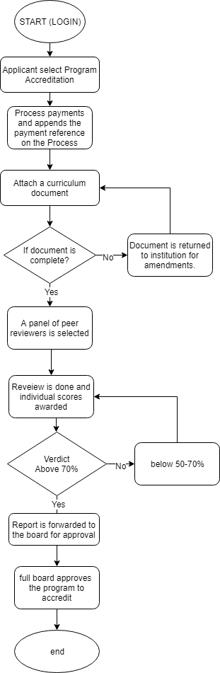

* 1. **Conceptual System Design**

This section summarizes the process flow of the accreditation module:

|  |  |
| --- | --- |
| **Process/Function** | **Design approach** |
| Applicant registers through the portal. Completes the online application with details. | * Categories of accreditation: institution, Program * Enforcement of completeness of the form (mandatory fields) * On application the system should have the ability to save the online application for completion later. (drafting). |
| Applicant pays the application fees as per the application fee schedule. | * Upon selection of the accreditation type, the system should display the amount of fee to be paid. * System should validate payment method * E-receipting/payment Notification-Acknowledging receipt of the payment * Capture payment reference details |
| Applicant submits application for approval | * Ability to attach supporting documents e.g. Curriculum document * On submission the applicant should receive a notification on successful submission * Submission of form should not be possible unless submission of payment reference is done, and all mandatory fields are filled. |
| Back office operations/ Accreditation decision process | * A panel is selected from a pre-qualified number of experts, resources * a peer review is conducted which involves subject experts’ evaluation on ground to ensure mentioned standards filled in the institution details match with the ground situation. * Either they accept and issue an accreditation certificate, or they reject and document goes back to peer review or evaluation stage. * System notifies the applicants of successful accreditations. |

**4.8. Proposed Database design**

The section below summarizes the system configuration and design approach for the accreditation module:

|  |  |
| --- | --- |
| **Process/Function** | **System Design** |
| Set-ups | Payments Setup   * Code * Type – {institution, program} * Institution Type (filter based on the type)   Amount  Accreditation processes setup   * Code * Description e.g. curriculum document review, site visit, sitting allowance, honoraria (Work types) |
| Institution onboarding | Institution (build from T18)   * No * Description * KRA P.I.N * Ministry of Education Code * Categories; Public chartered, Private university etc. * Sponsor; Government, Individual * Communication Details (T18) * County –(county setup table) * Constituency of Main Campus (from constituency table, to filter based on the county) * Type – Institution, Campus, college |
| Program | * Code, Description, Institution (Table Institution) * Program Domain (Table **Program domain)** * Program Sub-domain (from program sub-domain table – to filter based on program domain) * Program Level (Option String) – Certificate, Diploma * Accreditation Status – CUE Accredited, Senate Accreditation * Date of Submission * External Document No. * Date of Last Review * Date of Approval |
| Accreditation application | Accreditation table:   * Accreditation No. (Auto generated), * Campus No. (Populate institute data), * Other information (BLOB), * Payment details (Payment code, posted receipt no, Payment amount), * Status, * Timestamping details, * Attach supporting documents (documents stored on SharePoint and retrievable from NAV).   **Controls:**   * Ensure payment reference has been captured * Track documents based on application number |
| Panel Selection and Project (Accreditation) monitoring | Create a job from the accreditation card – it should book the invoice and create a receipt and create a job.  Job Planning Lines   * Add Individual Score field for the reviewer   Job task lines   * Weighted score   Job budget is defined on commencing of the project.  The individuals in the panel selected is created in NAV as resources.  Proposed controls   * Creation of a job only on paid and approved accreditation applications. * Notification to each resource on assignment of a job. * Ability to attach a commissioning letter and documents necessary on email to the respective resources assigned a project. * Ability to track consumption of budget and generate reports relating to it. * Ability to link a job and an accreditation application. * Ability to allow submission (Accrediting) of an application when the job Is marked as complete. |
| Back office processes on NAV (Board Approvals) | Accreditation Decision table:   * Accreditation no., * Type (Committee/Board/Secretariat), * Decision (Option: Major/Minor Revamp, Redesign), * Status (Approved/Rejected), * Date, * Accreditation stage (Application, Letter of interim Authority, Chartered).   **Receipting:**  The accounts team should receipt the non-refundable application fees. Key details to track on the receipt include Bank (Mapped to Bank listing), Receipt Date (Mapped to Application date), External Doc No (Payment Reference No), Customer Account (Mapped to Applicant A/C), Description (Application No) etc.  The double entry summary on receipting is as follows:  **DR:** Bank **CR:** Applicant A/C  Ability to generate automatic email receipts (Sent to applicant once posted)  Ability to link the posted receipt to the accreditation application (System populates the receipted amount).  **Approval/Workflows and accreditation process**  Standard NAV workflows to be activated to support approvals (Status changes from Open to Released) Once the application is fully approved, authorized users can run the score checklist report which is:   1. Sent to committee and board for final decision. 2. Application status changes to awaiting committee decision. 3. On approval the status changes to Awaiting charter for university and Accredited for programs.   **Key reports:**   * Application form * Payment listing * Payment receipt * Listing of accredited institutions and their programs |

**SECTION E: CONCEPTUAL BUSINESS PROCESS MODELS FOR DATA COLLECTION MODULE**

## **5.1. Proposed Database design**

The section below summarizes the system configuration and design approach for data collection;

|  |  |  |
| --- | --- | --- |
| **Process** | **Design Approach** | **Proposed controls** |
| Setups | 1. County – Code, Description 2. Constituency – Code, County, Description 3. Contacts – Role (T5066 – contact role responsibility), Blocked, Email 4. Program domain – Code, Description 5. Program Sub-domain – Code, Domain, Description, Blocked 6. Category (Income/Expense)-{option string} – Code, Description, 7. Acc. Sub-category – Code, Description, Category Code 8. Accounts – Code, Description, Category Code, Sub-category Code 9. Staff Ranks – Category, Code, Description e.g. full professor 10. Category - Code, Description |  |
| Institution | 1. Institution (build from T18)  * No * Description * KRA P.I.N * Ministry of Education Code * Categories; Public chartered, Private university etc.. * Sponsor; Government, Individual * Communication Details (T18) * County – from county setup table * Constituency of Main Campus (from constituency table, to filter based on the county) * Type – Institution, customer, Campus |  |
| Program | 1. Program  * Code, Description, Institution (Table Institution) * Program Domain (from Table **Program domain)** * Program Sub-domain (from pg. sub-domain table – to filter based on program domain) * Program Level (Option String) – Certificate, Diploma * Accreditation Status – CUE Accredited, Senate Accreditation * Date of Submission * External Document No. * Date of Last Review * Date of Approval |  |
| Students Enrolment Entry | * Entry No (Auto) * Student Master Records (ID/Passport/Birth Certificate, Surname, Middle Name, First Name, Gender, DOB) * Home County * Sponsorship (option string) – government, self-sponsored * Disability Type (from disability type setup) * Year of Study – yr1.yr6 |  |
| Graduation Entry Table | * Program code, * Cycle, * Student ID * University Code |  |
| Research | * Program Domain Code * University Code * Cycle * No. of Publications * No. of patents * No. of innovations |  |
| Staff Management | * Category {option string} – Academic, non-academic * ID/Passport No. * Surname, Middle Name, First Name * Ethnic Background (from ethnicity table) * D.O.B * Home County (from Home county) |  |
| Academic Staff Entry | * Cycle No., * Institution Code * ID/Passport No * Terms of service {option string} – full time, part time, * Program Domain (from Domain table) * Date of 1st Appointment * Rank –from ranks table * Highest Academic Qualification {PHD, Masters, Bachelors} * PF No. (Payroll No) |  |

**SECTION F: CONCEPTUAL BUSINESS PROCESS MODELS FOR QUALITY AUDIT MODULE**

## **System process maps for Quality Audit module**

* The commission communicates on an upcoming quality audit
* The institution pays depending on audit type: program or institution (payment is verified by the Accounting department)
* Attaches a self-assessment report
* CUE embarks on setting the quality audit dates.
* Institution is notified
* Panel selection
* Feedback sent to institution
* Institution sends a way forward on raised issues

## **Proposed Database design**

The section below summarizes the system configuration and design approach for data collection;

|  |  |  |
| --- | --- | --- |
| **Process** | **Design Approach** | **Proposed controls** |
| Setups |  |  |
| Institution | Institution (build from T18)   * Institution code (populates institution details) * Timestamping details * Payment reference no | * Ability to notify the Commission on institutions almost due for audit (6 months) * Ability to notify the institution of an upcoming quality audit. * Track quality audit payment |
| Program | * Institution code * Campus code * Program domain code * Program description * Payment reference no. * Timestamping details | * Notify the Commission of a program due for audit. (based on Cohort) * Notify the institution of an upcoming program quality audit, |
| Job(program/Institution) | * Creates a job on payment [if not impromptu] * Resources assignment * Job budget | * Ability to attach documents on email sent to the assigned resources. |

**SECTION I: CONCEPTUAL BUSINESS PROCESS MODELS FOR FINANCIAL MANAGEMENT**

## **7.1 Summary of core Financial Management**

The diagram below highlights the major business processes that shall be done or coordinated by the Finance department, and have a direct impact on the day to day use of Microsoft Dynamics NAV 2018:

### **7.1.1 Conceptual process map: Budgeting**



**Proposed controls:**

1. Preparation of Departmental sub budgets and related workflows
2. Consolidation to master budgets (Bottom up budgeting).
3. Authorized budget reallocation process.
4. Periodic variance Reporting-Budgeted, Actual, Commitments, Available funds.

### **7.1.2 Conceptual process map: Receipting**

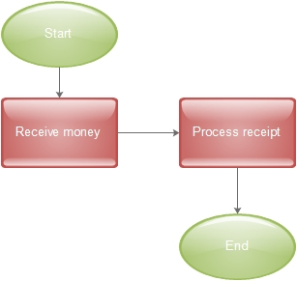

**N/B:** Sequential receipt coding for ease of reconciliation. The receipt should provide additional transaction summary. E.g. Accreditation etc.

### **7.1.3 Conceptual process map: Petty cash administration**



### **7.1.4. Conceptual process map: Imprest administration**

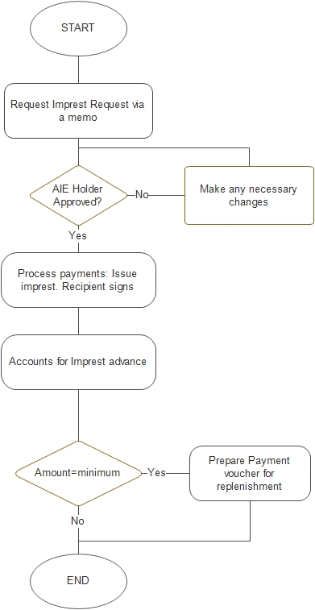

## **7.2 Conceptual system design**

|  |  |  |
| --- | --- | --- |
| **Functionality** | **Proposed Design** | **Controls** |
| Budgeting Process | * The Budget accountant/Finance Manager /Chief accountant sets up the Budget on NAV, with the correct Budget period and dimensions (e.g. department, branch, region etc.). The defined budget template is then exported from NAV as an Excel file. * The Budget accountant/Finance Manager /Chief accountant sets up the approved sub-budgets on the exported NAV budget template. * Excel budget file is imported into NAV and verified as a consolidated budget and as sub-budgets. The imported budgets can then be used for actual to budget comparisons/reporting | * Preparation of Departmental sub budgetsand related workflows * Consolidation to master budgets (Bottom up budgeting). * Authorized budget reallocation process.   Periodic variance reporting-Budgeted, Actual, Commitments, Available funds. |
| Customer payments/Receipting Process | * The receipting cashier receives and verifies the payment (cash/cheque/MPESA/EFT) [Off-system process]. * The cashier posts the payment on NAV and applies it to the correct invoice entries. * The cahier generates the payment receipt from NAV. |  |
| Vendor payment Process | * The payables accountant receives the required documents/paperwork to initiate payments processing e.g. copies of approved internal requisition, LPO, delivery note, goods receipt notes and supplier invoice [Off-system process]. * Such documentation is then verified against system-generated documents (generated during procurement process). The accountant must check that the documents have been approved and tally with what is reflected in the system * The payables accountant prepares the payment voucher which is approved by the chief accountant/finance manager * The payment voucher and related payment documents are the forwarded to the chief finance officer/CEO/Director for cheque processing (signing) or authorization for bank remittance * The payables accountant posts the payment on NAV and applies it to the correct vendor invoice entries. * The payables accountant generates the vendor remittance advice from NAV. |  |
| Imprest/Petty cash management Process | * Management approves the petty cash float to be maintained by the cashier * The cashier posts the allocated opening balance float (Dr. Petty Cash CR: Bank) * All staff allocated petty cash sign the petty cash receipt * The cashier posts all petty cash expenses against each signed receipt (there JUNE be a requirement for staff to attach supporting expenditure documents/receipts, as per the Company policy) * All un-authorized or un-accounted for expenditures JUNE be charged to the employee who was allocated the cash for recovery via the payroll, but this shall depend on the Company policy. * Periodic petty cash replenishment is done to restore the remaining cash amount to the authorized float. |  |

## **7.3 Proposed Design**

|  |  |
| --- | --- |
| **Functionality** | **Design Process** |
| Budget | * Budgeting should support budgeting per each department and broken down after receipt from the government into smaller units down to the line items of the chart of account. * The system should allow setting up supplementary budgets to cater for unforeseen situations e.g. penalties. * The system should allow budget checking. * Budget process to fully integrate with excels with ability to consolidate inputs from different departments, sectors into the main budget. * Budget module should allow setting of commonly used assumptions for re-use in future planning. * Budget planning to produce the monthly, quarterly and annual expenditure limits for each sector, project up to line item. * The system should support multiple budget within the same fiscal year. * Should support budgeting across fiscal years. * The system should support revision of budgets (done after 6 months by the board). * The system should be able to deduct any payments from the budget automatically. * The system should be able to allow authorized users (HODs and finance department) to monitor budgeted funds, committed funds, actual expenditures and balance at any point in time. * Ability to create activity based budgets by: Manual editing of prior budget, Percentage increase/decrease based on previous budget Zero based * Ability to save historical budget data * Ability to give different customized reports such as vote books, cash books, cheque books, voucher movement registers and payment vouchers. * Ability to maintain original budget and forecast on monthly, quarterly and yearly * The system to generate variance Analysis * System should allow a way of warning; in case the budget is exceeded. * The system should allow for reallocation of budgets (In case of under estimation and over estimation, or unused budgeted funds). * The system should allow submission of budgets for approval. |
| Receipting & Payment Voucher | * Bank account management - Create unlimited number of bank accounts, inter- bank account transfers capabilities and setup bank account with relevant information such as Account Number, Reserve Levels, Negotiated Interest Rates * Ability to process and post bank reconciliations in the system. * Ability to allow for payment/receipts reversal on specified dates not necessarily on original posting dates. * Ability to send notifications ones the Bank Accounts fall below set minimum limits * Ability to allow for specification of payments types including EFT, RTGS, Manual Cheques, System Cheques * Ability to allow for auto-generation of EFT, RTGS, System Cheque Numbers in the format of S/No./dd/mm/yy * Ability to notify payees Via Internet automatically. * Ability to generate bank specific payment files for uploading to external online payment systems. |
| Petty Cash Management | * Ability to allow for online application of petty cash (on designed petty cash form). * Automation of petty cash approval (1st Approver – Relevant Head of Department and 2nd Approver – General Manager Finance / Chief Accountant). * Ability to post an approved petty cash form on the system and having the system pass the correct GL entries once the cashier has issued out the cash (DR: Petty Cash Receivables CR: Petty Cash Till). * Ability for the cashier to post petty cash surrender/accounting transactions to a Petty Cash Surrender Form and its related documents. * The system should be able to pass the correct batched GL entries (DR: Expenses CR: Petty Cash Receivables) after a One Level Approval (Petty Cash Expenditure Examiner). In case of any returned cash, the system should be able to generate a Cash Receipt and pass the correct GL entries (DR: Petty Cash Till CR: Petty Cash Receivables) * Ability to send notifications ones the Petty Cash Till falls below the Replenishment Levels * Ability to generate an outstanding petty cash ageing report that shows amounts that are due for recovery (usually after 24 hours). * All system generated documents under the sub-module should have the ability to auto generate the numbers in the agreed format. * The system should not auto generate a new document without the previous document being utilized |
| Imprest management | * Automated Imprest Application Memo (I.A.M) creation and approval-The system should allow for the creation of the imprest memo as well as approval of the same * Ability to link each imprest memo to a specific Programs, with capability to map it to different dimensions * The system should have the control that an imprest applicant cannot apply for another imprest with an imprest balance * Imprest surrender processing- Automation of the Imprest Surrender Report document. * The system should have the ability for the Imprest Accountant to post surrender/accounting transactions and its related documents. The system should be able to pass the correct GL entries (DR: Expenses CR: Imprest Receivable). In case of any returned cash, the system should be able to generate a Cash Receipt and pass the correct GL entries (DR: Petty Cash Till / Bank CR: Imprest Receivable * Ability to generate an outstanding imprest ageing report that shows amounts that are due for recovery * Documents should only be visible / accessible to the relevant applicants |

**SECTION K: THE PROPOSED NAV 2018 SOLUTION DESIGN**

## **8.1 Conceptual model: financial management module**

The financial management module is made up of seven core sub-modules:

|  |
| --- |
|  |

### **8.1.1 Detailed navigation design for the financial management module**

|  |
| --- |
| 1. **GENERAL LEDGER** 2. Chart of Accounts 3. Budgets 4. General journals 5. Analysis & reporting 6. Account schedules 7. Analysis by dimension 8. Reports 9. Entries 10. Financial statements 11. VAT reporting 12. Consolidation 13. Miscellaneous 14. Setup list 15. History 16. History 17. Registers 18. Periodic activities 19. Recurring journals 20. Update analysis views 21. Intrastat journals 22. VAT 23. Currency 24. Fiscal year 25. **CASH MANAGEMENT** 26. Bank accounts 27. Cash receipt journals 28. Receipt Voucher 29. Payment journals 30. Bank account reconciliation 31. Receivables-Payables 32. Payment Vouchers 33. Petty Cash Voucher 34. Imprest Voucher 35. Reports 36. Register 37. Check details 38. Labels 39. List 40. Details trial balance 41. Receivables-payables 42. **RECEIVABLES** 43. Customers 44. Sales journals 45. Cash receipt journals 46. Invoices 47. Credit memos 48. Approval entries 49. Approval request entries 50. Combine shipments 51. Combine return shipments 52. Reports 53. Customer ageing report 54. Balance to date 55. Customer trial balance 56. Customer top 10 list 57. Documents 58. Customer statement 59. Customer payment receipt 60. Finance charge memo 61. Reminder 62. Invoice 63. Credit memo 64. History 65. Posted shipments 66. Posted invoices 67. Posted return receipts 68. Posted credit memos 69. Registers 70. Navigate 71. Periodic activities 72. Recurring journals 73. Reminders 74. Issued reminders 75. Finance charge memos 76. Issued finance charge memos 77. Setup 78. Sales & receivables setup 79. Payment terms 80. Payment methods 81. Reminder terms 82. Finance charge terms 83. Standard sales codes 84. **PAYABLES** 85. Vendors 86. Purchase journals 87. Payment journals 88. Invoices 89. Credit memos 90. Approval entries 91. Approval request entries 92. Reports 93. Vendor ageing report 94. Balance to date 95. Vendor trial balance 96. Vendor top 10 list 97. Documents 98. Vendor payment receipt 99. Invoice 100. Credit memo 101. History 102. Posted receipts 103. Posted invoices 104. Posted return shipments 105. Posted credit memos 106. Registers 107. Navigate 108. Periodic activities 109. Recurring journals 110. Setup 111. Purchase & payables setup 112. Payment terms 113. Payment methods 114. Standard purchase codes 115. **FIXED ASSETS** 116. Fixed assets 117. Insurance 118. FA G/L journals 119. FA journals 120. FA Reclass. Journals 121. Insurance journals 122. Reports 123. Fixed asset 124. Insurance 125. Maintenance 126. History 127. FA register 128. Insurance register 129. Navigate 130. Periodic activities 131. Recurring general journals 132. Recurring fixed assets journals 133. Calculate depreciation 134. Index 135. Setup 136. FA setup 137. FA classes 138. FA subclasses 139. FA locations 140. Insurance types 141. Maintenance 142. Depreciation books 143. Depreciation tables 144. FA Journal templates 145. FA Reclass. Journal templates 146. **INVENTORY** 147. Costing 148. Post 149. Adjust cost/prices 150. Adjust cost-item entries 151. Update unit costs 152. Inventory periods 153. Chart of accounts 154. Application worksheet 155. Analysis and reporting 156. Analysis reports 157. Analysis by dimension 158. Inventory – G/L reconciliation 159. Item dimension – details 160. Item dimension - total 161. Setup 162. Analysis types 163. Analysis line template 164. Analysis column template 165. Analysis view card |

**SECTION L: THE BACK-END DATABASE DESIGN**

## **9.1 Database management system design summary**

The Microsoft Dynamics NAV 2018 solution to be deployed at CUE runs on Microsoft SQL 2018 and later versions as the core back-end database management system.

The diagram below shows the tier architecture:

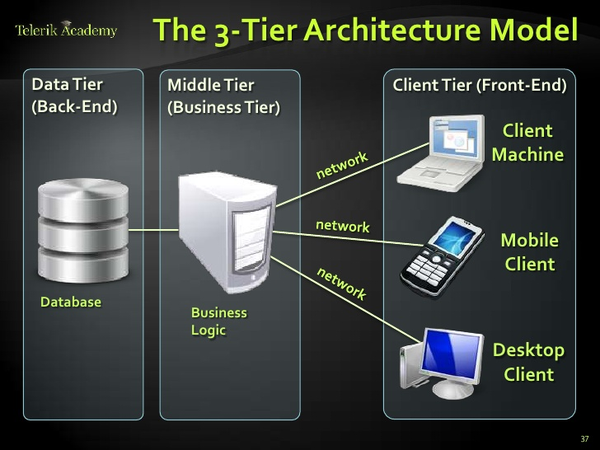

The Database tier facilitates storage of data while incorporating robust data manipulation routines.

The Microsoft SQL 2012 Server is a comprehensive database platform providing enterprise-class data management with integrated business intelligence (BI) tools. The Microsoft SQL Server 2012 database engine provides improved security and reliable storage for both relational and structured data. This enables development as well as maintenance of highly available, performance data applications.

NAV 2013 uses the following components of the Microsoft SQL Server 2012:

1. *Relational Database –* This is where the actual data is stored.
2. *Notification services* – It is used to provide alerts within the client tier of the NAV system e.g. wrong data format.
3. *Analysis services –* NAV uses the business analytics functionality embedded in SQL Server 2016 to provide different views of data to satisfy user queries.
4. *Reporting services* – NAV utilizes this facility for the design, management and delivery of rich reports.

This Document has been prepared by

Dynasoft Business Solutions Ltd

Date: 15th January, 2019.

